Design Simulation Report

**Team B**

|  |  |
| --- | --- |
| Vaibhav Mall | 7368641 |
| Zeeshan Swaveel | 7809323 |
| Ahmed Eloupy | 6517651 |
| Hanu Varshini | 7438059 |
| Glenn Ashley Pinto | 7395668 |
|  |  |

|  |  |  |
| --- | --- | --- |
| Topic | | Page number |
| 1. Title page, Contents and Explanation | | 1 |
| 2. Design and Simulation Results |  | 2-4 |
| 2.1. Finalized state machine | | 2 |
| 2.2. Flowchart | | 3 |
| 2.3. Arduino circuit | | 4 |
| 3. Feedback evaluation from deliverable 2 | | 5 |

Explanation (Recap)

Using an arduino mega for a medi-safe lock box which is battery powered and can be operated through 2 user inputs, an app and a button. We would implement it using a system of 3D printed funnels to sort the medicine pills according to their size.

**Per funnel -** It starts off in the idle state when powered on and it would then timely begin checking the humidity and temperature with a humidity and temperature sensor. If the humidity and temperature sensor reads excessive temperature or humidity, it will send an alert sent to the app and a request to the app for the need to refill, via authorized personnel, and return it to its idle state. It continues to await the press of a button. Once pressed it would check for pills using an IR sensor, if there are pills present, it will then check if enough time has passed in between doses. If, not enough time has passed, it will loop back to the idle state.

If enough time has passed, it will drop a pill from the funnel shaped containers within (each housing a different medicine), using stepper motors and a gear-like system into a box, where another IR sensor would check if the correct number of pills are present.

Per medi-safe box, we would have a system consisting of atleast 2 funnels

2. Design and Simulation results

**2.1 Finalized state machine and relevant multisim circuit-**

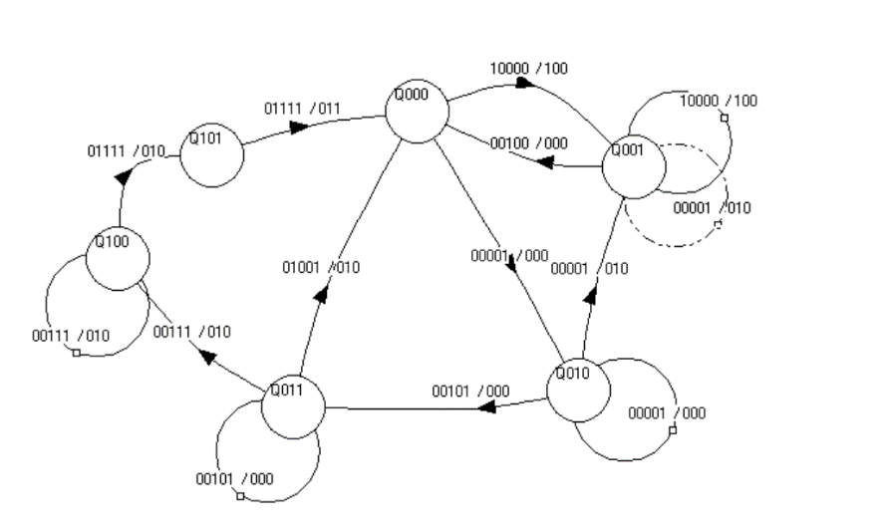

Figure 1) state machine

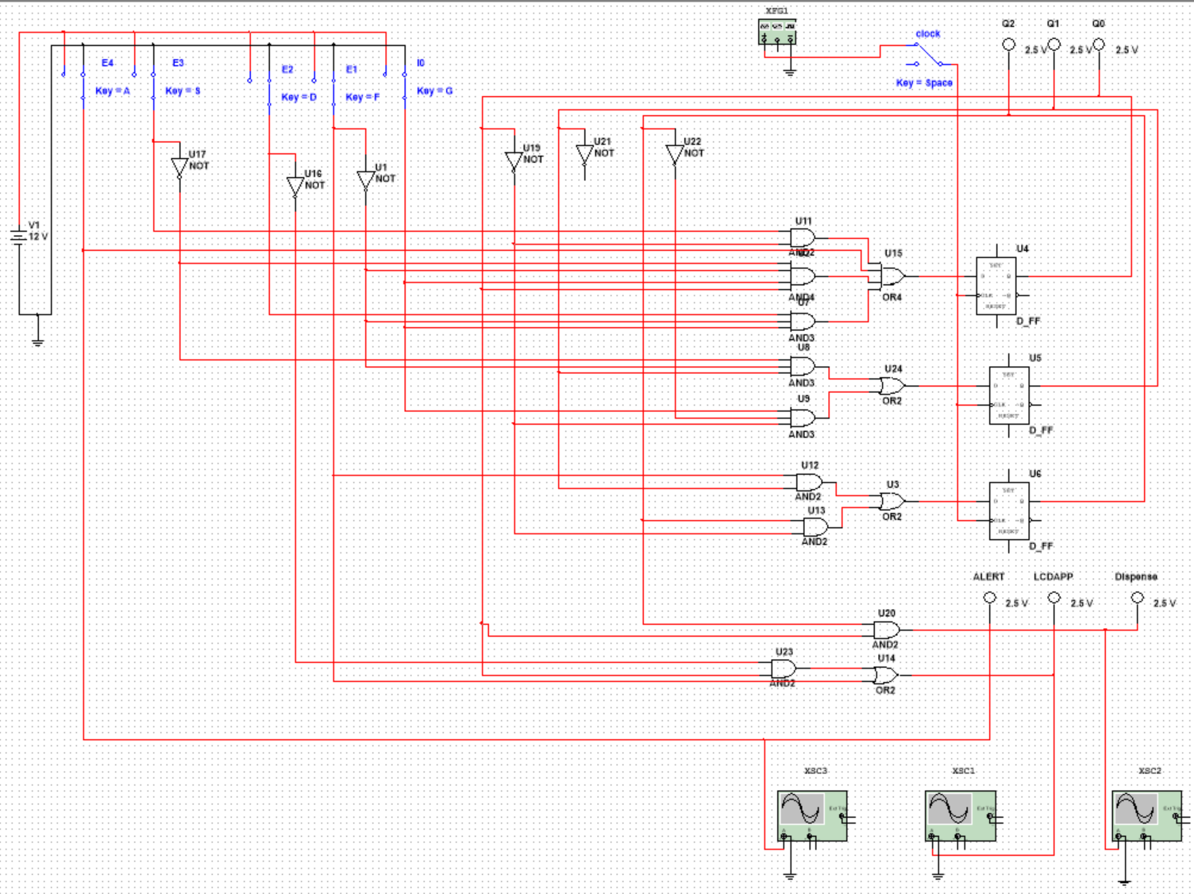

Figure 2) multisim circuit

|  |  |  |  |  |
| --- | --- | --- | --- | --- |
| X4 | E3 | E2 | E1 | I0 |
| Temp + Moisture sensor | IR sensor 2 | IR sensor 1 | Time | Button |

|  |  |  |
| --- | --- | --- |
| S2 | S1 | S0 |
| Alert | LCD | Dispense |

**2.2 Updated flowchart**

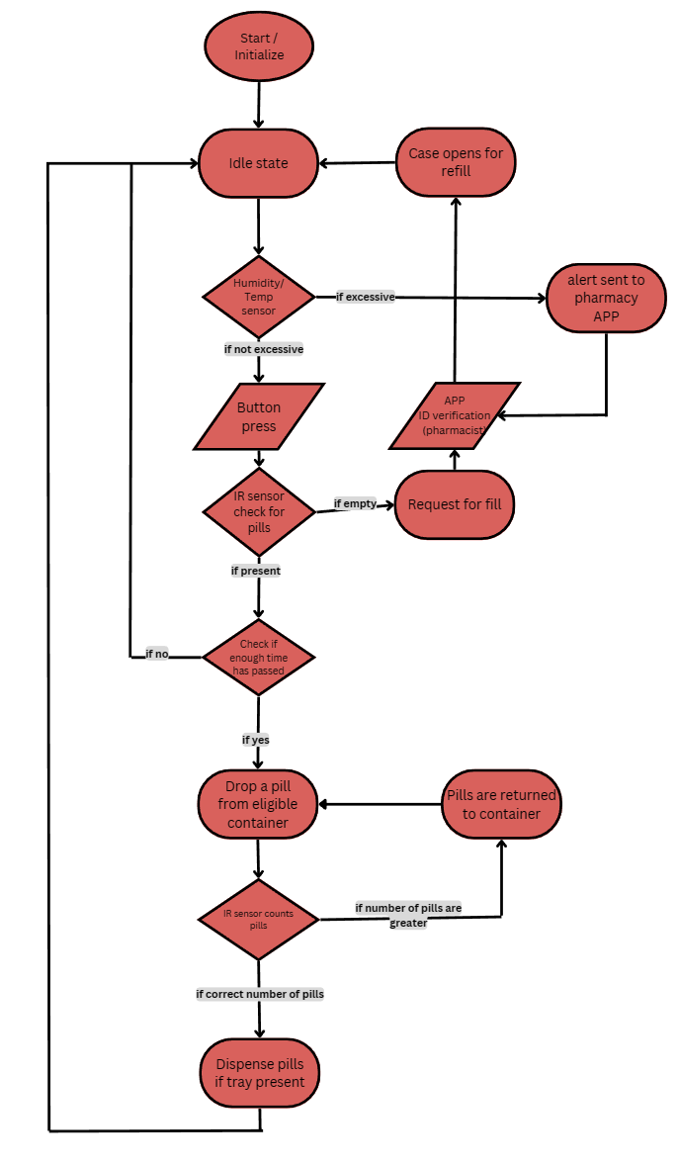

Figure 3) flowchart

**2.3 Hardware design**

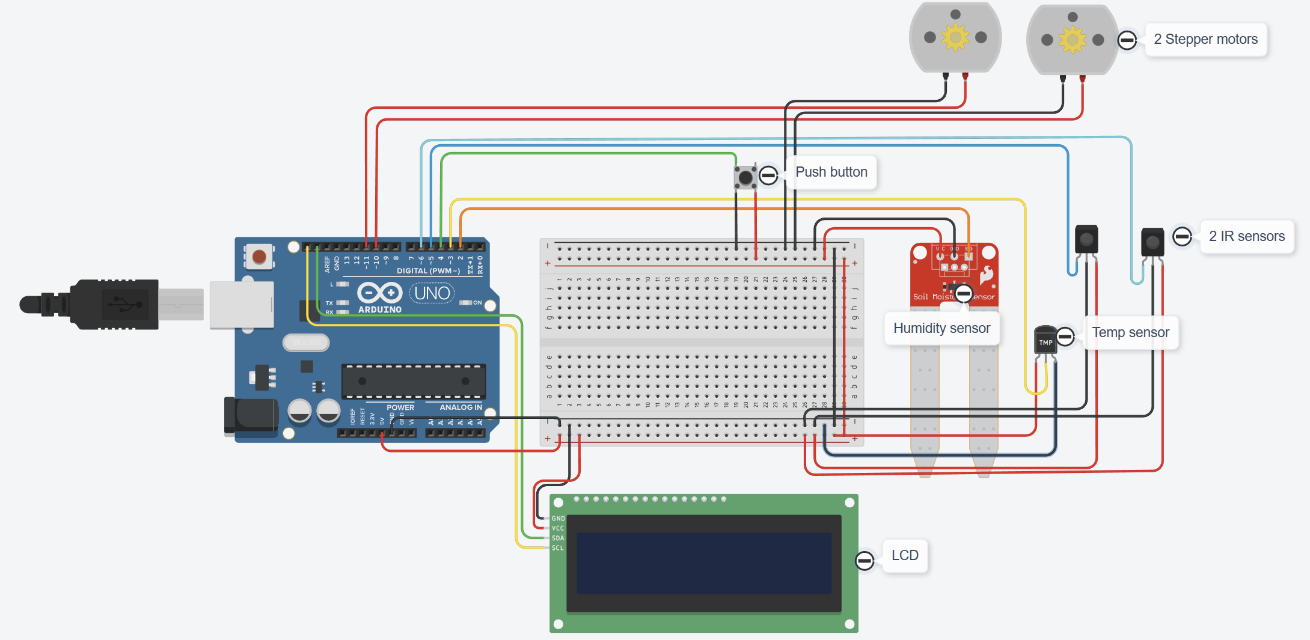

Figure 4) arduino circuit

This is the hardware design for one of the funnels and the final box

We intend to use the following components:

* 1 Arduino mega board
* 1 LCD display
* 2 stepper motors
* 1 moisture sensor
* 1 temperature sensor
* 2 IR sensors
* 1 push button

Explanation:

It would first start off with the checking of temperature and humidity levels using the moisture and temperature sensors respectively. If the values read by the Arduino is higher than the desired level, it would send an alert to the APP connected via an integrated wifi module. This check is repeated at set intervals, and if the check is passed, it then proceeds to await the press of the push button. Once pressed, it would then check with the first IR sensor, if there is a pill in the ends of the funnel, then it would check with the inbuilt timer, if enough time has passed, the first stepper motor would activate and drop pills into the box as per required in number. The second IR sensor would count the number of pills and then once done, the second stepper motor will dispense. Meanwhile, the LCD will display the progress of each step

Feedback evaluation from deliverable 2

1. Inconsistent report format and missing citations
2. Weight sensor problem
3. Block diagram explanation required
4. Create test cases

Adressing feedback-

1. The report format has been updated to include proper consistency. Our team apologizes for the lack of proper formatting. To fix this, we have implemented a proper and better structured format. Additionally, future reports will contain proper citations for sources as well
2. We have decided to implement the usage of 3D printed funnels instead of using weight sensors as they may be inaccurate and as well as for ease of use
3. Block diagram explanation

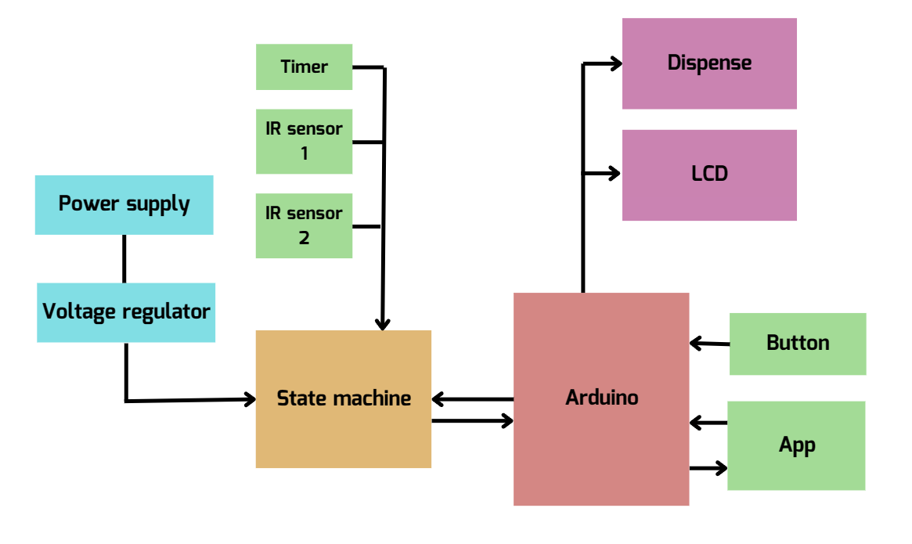

Figure 5) updated block diagram

The block diagram has been updated, and it runs as follows-

From the power supply, the voltage is regulated via an external (to be integrated) circuit to the state machine. The state machine would receive inputs from the Timer and IR sensors 1 and 2. The state machine would directly communicate with the Arduino circuit, which would be responsible for the button inputs and app commands. (The Arduino will also give outputs to the app). Finally the Arduino would control outputs in the form of the LCD and also dispensing the medicine.

1. Test cases

We have thought of the following test case.

A person could use the medisafe box after getting it from a pharmacist/caretaker. They would receive it filled already and would only have to use the button or app inputs. The care taker or pharmacist would receive the data on how medication is taken, and as well as have access to the medicine funnel compartments as well. They would have admin access to the lockbox and can help diagnose patients better.